**PHYSICS EQUIPMENT RECORDS MANAGEMENT SYSTEM**

**CASE STUDY: NAGONGERA CAMPUS**

**BY**

**AKELLO ROSEMARY**

**BU/UP/2020/1090**

**A PROJECT REPORT SUBMITTED TO THE DEPARTMENT OF COMPUTER STUDIES FOR PARTIAL FULFILLMENT OF BACHELOR OF INFORMATION TECHNOLOGY AT BUSITEMA UNIVERSITY**

**SUPERVISOR**

**DR. LUKYAMUZI ANDREW**

**DEPARTMENT OF COMPUTER STUDIES**

**FACULTY OF SCIENCE AND EDUCATION**

**NOVEMBER, 2023**

# DECLARATION

I **AKELLO ROSEMARY, Reg-No: BU/UP/2020/1090,** humbly hereby declare that this final year project report is the outcome of information concerning my own work.

Signature……………………………………………………..Date………………………………

# APPROVAL

This Project Report has been submitted with the approval of my caring supervisor.

Sign………………………………………………………….Date…………………………………

**DR. LUKYAMUZI ANDREW**

Department of computer studies

Faculty of Science Education

# DEDICATION

First and foremost, I dedicate this research project to the **ALMIGHTY FATHER GOD for** He has enabled me to start it and successfully finish it with a good health and sound mind. Sincere appreciation and dedication goes to my sponsors **HESFB (loan scheme scholarship)** for the financial support given to me, with a lot of much gratitude, I still extend my dedication and thanks to my only earthly parents **MR. WANDERA SAMUEL AND MRS. TAAKA JANE WANDERA** as well as my dearest siblings for you have played a lot for me to reach this level and May GOD continue blessing you abundantly. Special thanks to my supervisor **DR.LUKYAMUZI ANDREW** who guided me through the project making plus this report. Lastly I thank everyone that has put his/her effort seeing me reach the apex of this educational level for example my lecturers who taught me the fundamentals, 10 course mates especially **Billy Nikolas** with **Sande Alex,** not forgetting the physics laboratory assistant **MR. Edward**  who allowed me to smoothly conduct my research,May the Great One bless you abundantly.

# ACKNOWLEDGEMENT

First and foremost I would like to glorify the **Almighty FATHER** for the life, care, favor, knowledge, wisdom and understanding because I personally believe that I have been successful in my academics due to **His** love towards me.

Great thanks to my parents **Mr. Wandera Samuel** and **Mrs. Taaka Jane Wandera**  for they have extended a lot of unconditional love and support to see my academic success, as well as my sponsors **HSFEB (Loan Scheme)** who rendered me tuition up to this peak.

In the same mood, I still extend my wide smile and thanks towards my loving lecturers who acted as parents, counselors, teachers as well as supervisors in the time of study most especially my project supervisor **Dr. Lukyamuzi Andrew,** for he gave a lot of guidance from the start to the end of this project. I was able to choose the best and comfortable topic of study through his guidance in terms of research conduction.

In addition to that, great appreciation goes to the physics laboratory attendant, Busitema University, Nagongera Campus **MR. Edward Richard,** for he gave me a free and comfortable ground to make my research within his field of work by giving me positive responses without showing a poor attitude.

Lastly, I acknowledge all my friends, relatives and the whole Nagongera community that always encouraged me in every situation especially my sister Nakato Hellen, my one and only female course mate Achieng Lydia, Madam Kisakye Diana Michelle, Mr. Musana Eddie, Billy Nikolas, Sande Alex and my other colleagues, May GOD bless you.

# TABLE OF CONTENTS

Contents

DECLARATION i

APPROVAL ii

DEDICATION iii

ACKNOWLEDGEMENT iv

TABLE OF CONTENTS v

LIST OF FIGURES viii

LIST OF TABLES ix

ABSTRACT x

LIST OF ABBREVIATIONS AND ACRONYMS xii

CHAPTER 1: INTRODUCTION 1

Background of study: 1

Problem statement 3

Purpose of the study 3

Specific objectives 3

Significance of the study 4

Scope of the study 4

CHAPTER 2: LITERATURE REVIEW 5

Introduction: 5

Terminologies 5

Physics 5

Physics laboratory equipments 5

Physics laboratory technicians or assistants. 6

Records 6

Records management 7

System 7

Information systems. 8

Management Information systems (MIS) 8

Online 9

Review 9

CHAPTER 3: METHODOLOGY 11

Introduction: 11

Research design 11

Area of the study 11

Sampling and sample size 11

Participants in sample 12

Data collection methods 12

Interview 12

Observation 13

Documents review 13

Data collection instruments 13

Interview guide 13

Observation checklist 13

Document review 14

Data analysis and presentation 14

System Design 15

Context diagram 15

Data flow diagram (DFD) 15

Use-Case Diagram 15

System implementation software and tools 15

Testing and validation 17

Testing 17

Validity 17

Ethical considerations 17

CHAPTER 4: SYSTEM ANALYSIS AND DESIGN 18

Introduction: 18

Current system study: 18

Strengths of the current system 19

Weaknesses of the current system: 19

System Requirements: 20

Functional requirements: 20

Non-functional requirements 21

Hardware/ Software requirements 22

Hardware requirements 22

Software Requirements 22

System Design: 22

System Architecture: 22

System Context Diagram 24

Data flow diagram 25

User case diagram 26

System Entity Relationship Diagram (ERD) 27

Database Design 28

User interface designs 31

The logging interface 31

Welcome page for administrators 31

Welcome page for equipment borrowers 34

CHAPTER 5: IMPLEMENTATION AND TESTING 36

Introduction: 36

System implementation 36

System testing 50

Unit testing; 50

Integration testing; 50

CHAPTER 6: DISCUSSION, CONCLUSION, RECOMMENDATIONS, LIMITATIONS AND FUTURE WORK 51

Introduction: 51

Discussion 51

Conclusion 52

Recommendations 52

Limitations 53

Future work 53

REFERENCES 54

APPENDICIES 55

APPENDIX A: Open-ended interview questions 55

APPENDIX B: TIME SCHEDULE 56

# LIST OF FIGURES

**Figure 1 Architectural design of system** 24

**Figure 2 System Context diagram** 25

**Figure 3 Perms data flow diagram** 26

**Figure 4 System use case diagram** 27

**Figure 5 Perms Entity Relationship Diagram** 28

**Figure 6 Login design** 31

**Figure 7 Admin-welcome design** 32

**Figure 8 Equipments page design** 32

**Figure 9 Borrowed equipments design** 33

**Figure 10 Fines design** 33

**Figure 11 Borrowers-welcome design** 34

**Figure 12 Borrowers-profile design** 34

**Figure 13 Available equipments design** 35

**Figure 14 Borrowers-fines design** 35

**Figure 15 welcome screen** 36

**Figure 16 login page** 37

**Figure 17 Navigation bar for admin** 37

**Figure 18 navigation bar for borrowers** 38

**Figure 19 announcements** 38

**Figure 20 Administrators** 39

**Figure 21 Borrowers table** 40

**Figure 22 Generate report** 40

**Figure 23 Equipments table** 41

**Figure 24 print report page** 41

**Figure 25 generated report** 42

**Figure 26 update equipments** 42

**Figure 27 Borrowed equipments** 43

**Figure 28 managed Fines** 44

**Figure 29 welcome page for borrowers** 45

**Figure 30 Borrowers account** 46

**Figure 31 Borrowers profile edit** 46

**Figure 32 Available equipments** 47

**Figure 33 Borrow page** 47

**Figure 34 borrower's fines** 48

**Figure 35 admin-tb** 48

**Figure 36 News-tb** 49

**Figure 37 Equipments-tb** 49

**Figure 39 equipmentsCategory -tb** 49

**Figure 40 Borrow -tb** 49

**Figure 41 Borrow-tb** 50

# LIST OF TABLES

**Table 1 Respondents perception about equipments records management** 12

**Table 2 system users and their respective requirements** 20

**Table 3 Administrators' table** 29

**Table 4 Borrow table** 29

**Table 5 Equipment categories** 29

**Table 6 Announcements** 30

**Table 7 Equipments** 30

**Table 8 Members/Borrowers** 30

**Table 9 Project time schedule** 56

# ABSTRACT

The physics equipments records management system (PERMS) was developed as a web-based record system designed to help laboratory technicians be able to take record of the new stock, lend equipments then penalize the defaulters who borrowed equipments and took long to return them back. This could help to avail equipments for use to other members who would wish to borrow. This could also help the laboratory assistant to be able to know the approximate number of the normal and available, disposed, scrapped equipments in the laboratory hence giving a better budget to the procurement department of the university.

The system consisted of two sessions for example the laboratory assistant’s side who acted as the administrator and on this side this client was able to easily announce what was required in the laboratory, added new normal, disposed and damaged equipments into the system, controlled accounts then finally managed borrowed equipments through fines. The other side contained the equipment borrower’s interfaces where he/she was able to view announcements, edited profiles, borrow equipments then finally view the debts or remaining days.

Another section is the navigation panel that required a user to first login before he/she penetrates the whole system. The laboratory assistant was able to update the equipment statuses, added borrowers and other admins, made changes on accounts and also stopped the counting of the fines for a specific borrower as long as one returned the equipment or even paid for the fine. He was also able to generate reports for some events in specific periods.

The major reason as to why I carried on this research was to help the physics laboratory assistants to overcome the manual way of keeping records on the equipments details, borrowers as well as managing borrowed equipments by imposing fines on those who borrowed and return passed the return dates. The methodology that was first applied was SSAD (Structured System Analysis and Design) used for analyzing and designing the structure of the system. This was followed by the RAD (Rapid Application Development) methodology which was easy to implement to a working system and saved time and finally the prototyping methodology was also applied since the researcher was able to deliver the simple parts of the system sometimes to the laboratory assistant to check and direct him where improvements were required. For the management of database, the researcher used MySQL and phpMyAdmin as my IDE to normalize, store and update data as well as other activities on data like MySQL Workbench to draw the data structures. With text editors, visual studio was used.

Furthermore, the researcher used PHP to link the MySQL for the database and the HTML, the Html for creating web pages and forms, Java Script for Popups, alerts or notifications, JQuery for providing features on tables, Fpdf for creating and printing PDFs reports and CSS for styling pages as the programming languages as well as bootstrap as one of the new technologies (libraries) used to make multiple page styling easier. Lastly but not least, the researcher used Xamp local server to probably host the system on the local device and the system itself was simply accessed through web-browsers like Google chrome and Internet explorer.

# LIST OF ABBREVIATIONS AND ACRONYMS

PERMS Physics Equipments Records Management System

HTML Hypertext Markup Language

PHP Hypertext Preprocessor

FPDF Free Portable Document Format

CSS Cascading Style Sheet

IDE Integrated Development Environment

SSAD Structured System Analysis and Design

RAD Rapid Application Development

PDF Portable Document Format

DFD Data Flow Diagram

ERD Entity Relationship Diagram

ERP Enterprise Resource Planning

MIS Management Information System

DBMS Database Management system

MFIPPA Municipal Freedom of Information and Protection of Privacy Act

# CHAPTER 1: INTRODUCTION

## Background of study:

Physics is a natural science that studies the fundamental principles governing the behavior of matter, energy, space and time. It seeks to understand and explain the physical laws that govern the universe from the smallest particles, like atoms and subatomic particles to the largest celestial bodies like galaxies and the entire cosmos. Physics is the study of dynamics (Brown 2013). Dynamics is the description of the actual forces of nature that we believe, underlie the causal structure of the universe and are responsible for its evolution in time.

Physics plays a crucial role in our understanding the natural world and has significance in various aspects of human life and society for example allowing us to develop sustainable and renewable energy sources to address the global energy challenge and combat climate change among others.

It is through physics that new methodologies were developed that helped improve the quality of life, including things such as automobiles and modern construction (Gurikar 2015). In 1999 during the world conference on science (WCS), the UNESCO- Physics Action Council considered physics an important factor in developing solutions to both energy and environmental problems.

The purpose of physics as a subject can be possible through the use of some equipments which refer to the wide range of tools and apparatus found/stored in a building (laboratory) used by physicists and physics students for conducting scientific research or for lecturing practical science, as for carrying out scientific experiments.

Physics laboratories in universities store these equipments in various categories to facilitate practical experiments and research and among these we have, optical bench, spectrometer, cavendish balance, van de Graaff generator, magnetic field apparatus mention but a few.

Teaching physics without adequate and functional instructional materials especially laboratory apparatus may certainly result into poor academic achievement, inadequate exposure to science laboratory work at the secondary school level has been a major cause of first year university students’ inability to comprehend and apply scientific knowledge (Danjuma and Adeleye 2015).

Science education requires schools to have appropriate laboratory equipments to facilitate learning effectively because in every experiment, the equipments are essential in accurate data gathering. Therefore, the equipments should be properly managed to ensure that they are available when needed and that can be used in ways that maximize their lifespans.

There are a number of different ways to manage these equipments records for example; Manual management which involves writing done details about a specific equipment, people who use the equipments on the daily basis using pen and paper. Then we also have the computer-based way where one can easily create an equipment inventory and also make various transactions on the equipments by the borrowers (lecturers/students) then also storing information in a web-based database.

Nagongera campus physics laboratory belongs to the physics department under the faculty of science and education which is one of the seven branches of Busitema University. It is located in Nagongera Town council, Tororo district, eastern region of Uganda.

This campus offers a variety of undergraduate and postgraduate programs in science, education and related fields. It has a number of research facilities, including a library, a computer laboratory and a number of laboratories for conducting scientific research.

The physics laboratory assistants use the word document files to take record of each of the activities that take place in the building however they face a lot of challenges while using such files ie they are not very flexible, they can be difficult to customize to meet the specific needs of a physics lab, vulnerable to errors, such typos and formatting errors, difficult to share, especially with users who do not have Microsoft word installed on the pc, the files are also not scalable and they become difficult to manage as the number of records increases.

The laboratory assistants also use physical/tangible note books to record information about various people (lecturers/students) who visit and borrow the in equipments in the lab for research/practical. This can be risk because there can be loss/displacement of the books and it’s also tiresome writing down the record of each session.

Therefore, a physics equipments management system is a system that enables the physics lab assistant of Nagongera to add other assistants as system administrators, giving them confidential passwords that enhances safety of each other’s session in the system, add equipment users (students and lecturers) alongside with their accounts, generate reports, print reports, filter and display specific needed items.

The equipment users are able to borrow the equipments and also indicate expected return date in order to provide the equipment for other people to use. This is very possible because the system fines victims who tend to stay with the equipment passed the return date they promised to return it. The system also helps the lab assistant(s) to announce the news to all users about the lab activities when necessary hence easing his/her work.

## Problem statement

The physics equipments used are regularly managed and maintained by the laboratory technicians who play a big role in taking records of the equipments and borrowers. Most laboratory technicians use a manual way to store details of the equipments in the lab as well as information about people who borrow such equipments by use of note books or word document files. They also use the same methods to generate timely reports which may be hectic and impossible for them to track the equipments and borrowers’ records afterwards. This makes it hard for them to monitor the use and movement of such equipment making them vulnerable to damage and external factors like theft.

The physics equipment records management can adjoin records management principles which consist of authenticity, availability, security, disposal, compliance, transparency, accountability and preservation. The compliance to the eight principles foundational to the electronic records management system is to ensure that the security and quality of records are not compromised(McLeod and Hare 2006).

Therefore I have developed a web-based system that can store all such details within the reach of the laboratory technicians making their work much easier.

## Purpose of the study

To design and implement a web-based physics equipments records management system that will be used to manage equipments records as well as get information regarding borrowers.

## Specific objectives

1. To review the literature and determine the equipments for developing the physics equipments records management system.
2. To design the system for the physic equipments records management system.
3. To implement the design of the physic equipments records management system.
4. To test the functionality of the physic equipments records management system.

## Significance of the study

On the successful development and further implementation of the physic equipments records management system, the study led to the following significances;

* The Physics equipments records management system will enable the physics laboratory assistants to be able to store records of the equipments and borrowers. For example keeping new equipment details, borrower’s details, updating equipment status in case of change, monitoring borrowed equipments according to return date as well as fining those who take long without returning the apparatus.
* The Physics equipments records management system will also contribute to future research once approved by the department supervisor, other student may have interest in developing projects in the same line with it or even add on more improvements where necessary.
* Furthermore, the Physics equipments records management system can be applied in related areas like chemistry, biology, ICT laboratories as well as library at the learning institutes since they contain items to be borrowed and used by learners in their convenient time and places

## Scope of the study

The research was conducted from the physics laboratory under the physics department at Nagongera campus (faculty of science and education) of Busitema University and it’s located in Nagongera town council, Tororo district, in the eastern region of Uganda. The study focused on the physics equipments records management and aimed at simplifying the work of the laboratory assistants while taking record of the equipments and managing their usage. It took approximately six months for it to become complete and the scope of the area coverage included the details of the equipment users and the system administrators.

The equipments users were able to login then do various things in their sessions ie, edit profiles, view available equipments for borrowing, view the fines posed onto them and lastly borrow an equipment for in case one was interested.

The lab assistant played a role of being the administrator and was able to register or add other admins who can assist him for in case of his absence, add and edit equipments, add and edit equipment borrowers, stop the fining of someone who has brought back the equipment as well as paid the over dues where necessary, update announcements concerning the laboratory activities.

# CHAPTER 2: LITERATURE REVIEW

## Introduction:

This chapter comprises of a comprehensive analysis of information on theoretical and practical views of others research projects conducted in physics laboratories for management of equipments records both manually and electronically. It enabled the researcher to get a more clear understanding of equipments records management systems as it provided an insight about the topic under study, points out what other researchers have done provided the background information needed for research question, guided the identification of research of gap, provided a guide to the boundary of the research aided in the creation of a link between what had been done and what was being done. It was sub-divided into different sections for example information systems, reviews on the existing systems in real-world scenarios. Loopholes of the current system, relevance of the physics equipments records management system that was to be built.

## Terminologies

### Physics

Physics is a natural science that studies the fundamental principles governing the behavior of matter, energy, space and time. It seeks to understand and explain the physical laws that govern the universe from the smallest particles, like atoms and subatomic particles to the largest celestial bodies like galaxies and the entire cosmos. Physics is the study of dynamics (Brown 2013). Dynamics is the description of the actual forces of nature that we believe, underlie the causal structure of the universe and are responsible for its evolution in time.

### Physics laboratory equipments

Laboratory equipment refers to the various tools and equipment used by scientists working in a laboratory. Laboratory equipment is generally used to either perform an experiment or to take measurements and gather data. Larger or more sophisticated equipment is generally called a scientific instrument.

At the dawn of the twentieth century technical and polytechnical schools, scientific departments of universities, and sometimes industrial laboratories had important collections of scientific instruments. The wealthiest institutions kept in their store rooms up to several thousand different apparatus which usually came from the best British, German, and French workshops. Though most of the instruments were produced by specialized firms, many scientific laboratories had their own workshop where highly skilled technicians could repair and modify the apparatus or, in some cases, build special instruments and prototypes (Brenni, 2013).

### Physics laboratory technicians or assistants.

A laboratory technician is a scientist who conducts experiments and analyzes data in a laboratory setting. They work in a variety of fields, including medicine, biology, chemistry, and physics. Laboratory technicians play an important role in scientific research and development by providing accurate and reliable data that scientists can use to make informed decisions.

### Records

The MFIPPA is an act to promote access to information held by government and to protect the privacy of personal information which provides the public with a right of access to records collected by government, subject to limited and narrow exemptions. It defines a record as follows:

A record is recorded information however recorded whether in printed form, on file, by electronic means or otherwise and includes correspondence, a memorandum, a book, a plan, a map, a drawing, a diagram, a pictorial or graphic work, a photograph, a film, a microfilm, a sound recording, a videotape, a machine readable record, any other documentary material, regardless of physical form or characteristics, and any copy thereof.

It further states that any information that is capable of being produced by a machine and subject to the regulations any record that is capable of being produced from a machine readable record under the control of an institution by means of computer hardware and software or any other information storage equipment and technical expertise normally used by the institution.

Records are important for their content and as evidence of communication, decisions, actions, and history. As public institutions, school boards/authorities are accountable to the public and to government. Records support openness and transparency by documenting and providing evidence of work activities and by making them available to the public. Records support quality program and services, inform decision making, and help meet organizational goals.

### Records management

Records management, also known as records and information management, is an organizational function devoted to the management of information in an organization throughout its life cycle, from the time of creation or receipt to its eventual disposition. This includes identifying, classifying, storing, securing, retrieving, tracking and destroying or permanently preserving records.

["ISO 15489-1:2001"](https://en.wikipedia.org/wiki/ISO_15489_Information_and_documentation_--_Records_management" \o "ISO 15489 Information and documentation -- Records management) defines records management as the field of management responsible for the efficient and systematic control of the creation, receipt, maintenance, use and disposition of records, including the processes for capturing and maintaining evidence of and information about business activities and transactions in the form of records.

### System

A system is a group of components (people, objects and processes) that work together to achieve a common goal, or multiple goals, by accepting input, processing it and producing output in an organized manner. There are people, objects and processes in computer systems, the processes are for example computer programs and the objects are the computer hardware. Every system be it computer based or not has to accomplish the activities required for it. Therefore, what all systems have in common is a goal out of some desire to overcome a certain set of tasks (Webster, 2002).

A system consists of three major components including the input which implies something that goes into the system, the processes which is defined as type of work that must be accomplished in the system and lastly the output which is a desired product that must be produced. Regarding physics equipment records management system, the input includes the equipment details by the laboratory technician, the process includes the borrowing equipments, fining borrowers and generating timely reports. Lastly the output is the printed report as well as stored equipment records

### Information systems.

An information system is a set of interrelated components that collect, manipulate, store and disseminate data and provide a feedback mechanism to achieve a specific objective (Dickson and Wetherbe 1985). The use of automated information systems has resulted into improved faster and efficient means of information collection, processing, store, distribution and retrieval, information system is also a reliable tool that can be used in building the financial information required in decision making for proper planning and budgeting of the resources in an organization. There are different types of information systems that is to say, Management information systems, Transaction processing systems, Enterprise Resource Planning (ERP) systems, customer relationship management systems, among others.

### Management Information systems (MIS)

Management information systems are systems that take information captured and recorded by other systems such as transaction processing system about the transactions that affect the organization and produce reports that management needs for proper planning and controlling the enterprise.

Protection and management of records from destruction is important task as they provide us evidence of legal status, ownership, accounts received and the participants of obligations required by the government agencies or private organizations.

The increasing number of students majoring in physics as a subject plus the lecturers teaching as well as equipments being used in the laboratory for research or even practical lessons, has led to the use of management information systems to protect records about transactions occurring during each session. A computerized technology is being adopted in recording equipments details, the borrowers’ details, and the transaction details concerning how things have been carried out each session. This is done in order to recognize the benefits and challenges of the complex manual system as well as deeply understanding how much the university has in stock plus the status of each.

The management information systems provide accurate, timely, less labored, relevant complete information necessary to facilitate decision making in the organization ie the lab assistant can be able to request in for more equipments basing on the amount he has in stock. It also helps in planning, controlling and operational functions to be carried out effectively and efficiently.

### Online

The word online means anything connected to, served by or available through a system and especially a computer or telecommunications system (such as the internet) (Webster, 2002). This implies that the system is to operate under the direct control of a computer thus the equipment requests and stock taking as well as management phases are to be done online though for one to get the equipment, will be physical.

## Review

An online physics laboratory management system is a web-based application that facilitates keeping of laboratory records by the laboratory technicians, as well as the borrowing of laboratory equipment by the faculty students. This eradicates paperwork and eases the operations of the laboratory.

Before, computers and software data management in laboratories was a tedious and time-consuming task. With handwritten laboratory reports and charts, there was a higher probability of human error to occur. Laboratory information management systems (LIMS) were only first developed for personal use by the early 1980s. In 1982, the first-generation commercial LIMS was created providing the first automated reporting features. By assigning laboratory functions to a centralized computer, productivity and functionality improved.

As technology advances and work flow changes, the need for application specific features emerged. This initiated the development of second-generation LIMS which was possible by using third-party commercial relational databases through the use of minicomputers. By the early 1990s the first client/server configuration was developed using a PC combined with the security of a minicomputer. Functionality “appeared” quicker by splitting the data processing between several clients and the main database server. Fourth-generation LIMS was developed by the mid-1990s which allows distributing client/server functions over a network to optimize processing and sharing capabilities.

In 1996, the internet advanced and initiated the first web-enabled and wireless computing features for LIMS. Now, LIMS are packed with full functionality for laboratories to immediately benefit from increased productivity after implementation.

Following the demands in the implementation of the new curriculum, wherein science learning emphasizes scientific approaches and methods of discovery (inquiry), then in each learning process science requires laboratory-based activities. This is following the results of Suseno’s, Partono and (Suseno, 2019) that the use of teaching aids combined with analogies can help the discovery process in the abstract concept of science. Besides (Suseno, 2019) also found that practicum-based learning on the concept of metabolism can improve critical thinking skills.

Based on some of the opinions above, the role of school laboratories is significant in supporting the learning process. So that it is necessary to strive for good school laboratory management, and administration so that the physics laboratory can be used more efficiently in the learning process. Research (Novianti, 2011) found that: “the contribution of science laboratory management and student learning motivation for the effectiveness of the learning process shows a fairly strong level of contribution.”

# CHAPTER 3: METHODOLOGY

## Introduction:

This chapter covers the research design, the population of this study, the data collection tools that were used in the course of the research, data collection instruments that were used in the process of data collection and techniques to maintain the validity and reliability of the research instruments.

## Research design

A research design as a general strategy adopted for answering the research questions. It is a plan of what data to gather, from who, how, when to collect and how to analyze the obtained data. The research design provides the glue that bonds the research project together.

A research design outlines the basis for making interpretation of the data and establishes detailed steps to follow when conducting the study. This study used a case study design.

Yin (2009) I states that the case study design may refer to an empirical inquiry that investigates contemporary phenomenon in depth and within its real life context. It is mostly used when conducting research in social sciences. The researcher used a case study design because the researcher wanted to investigate storage and retrieval of equipments records as well as equipment users’ details at the faculty of science and education in the physics laboratory, Busitema University.

## Area of the study

Population can be defined as the complete set of individuals, objects or measurements having same common observable characteristics. The population enabled comparison of the study samples in relation to their characteristics and differences. Nagongera campus has the population of around 58 students who do physics as a subject and 10 lecturers who lecture physics then also 2 assistants in the laboratory.

## Sampling and sample size

A sample can be defined as a portion of the population which is deliberately selected for purposes of research. He further asserted that, it’s a process of selecting a number of individuals or objects from a population such that the selected group containing elements respective of the characteristics found in the entire group. In this case, the researcher used purposive sampling methods and selected the laboratory attendants, physics students and physics lecturers to enable the researcher to make better conclusions on the findings of the study.

The study established that the laboratory assistant was responsible for records related to the equipments details, equipments users’ details, transactions that take place while borrowing an equipments, fines imposed onto those who don’t follow laboratory rules and finally the details of the other laboratory assistants as the system administrators.

## Participants in sample

|  |  |
| --- | --- |
| **Respondents** | **Number of respondents** |
| Laboratory assistant | 1 |
| Physics students | 3 |
| **Total** | 4 |

**Table 1 Respondents perception about equipments records management**

## Data collection methods

Data was collected using interviews and observation.

### Interview

Interviews are a versatile data collection method that can be used in qualitative, quantitative and mixed methods research, **John Creswell** (2009). This method can be used through personal interviews and if possible, through telephone interviews. The researcher used this method to collect data from the laboratory assistant and the physics students. Using this method, the research was able to get in depth information about types of equipments details, borrowing terms and fines then maintain the good usage of equipments in the physics laboratory at faculty of science and education of Busitema University, storage methods, retrieval procedures as well as challenges faced in managing those records while using a physical notebook and word document files.

### Observation

(Goffman 1967) argued that the best way to understand social interaction is to participate in it. Observation enabled me as the researcher to employ vision in identifying the ways how the lab assistant takes records of people’s detail who borrow equipments for usage then I was also able to see the notebook that contains all the above. I was also able to see one of the word documents containing information about added equipments and their statuses. Therefore, the researcher designed an observation guide in terms of visiting time and date (lab) to act as a road map to the aspects highlighted above.

### Documents review

Documents are materials which contain information about a phenomenon the researcher wishes to study. The researcher reviewed published and unpublished literature from textbooks. Journals, newspapers and reports. The researcher employed the documentary 18 sources because they were very cheap as compared to other sources and researcher never expected to pay huge sums of money to access the information.

## Data collection instruments

### Interview guide

An interview guide is a set of topics or questions about which interview is conducted. (Young, Schmid et al. 1947) argued that interview guides can be used to collect data on a variety of topics such as attitudes, beliefs, and behaviors. This involved asking the respondents face to face questions and was done with the help of designed interview guide where the interview asked relevant questions to the interviewee since there was direct interaction. This method enabled the interviewee to freely respond to issues thus the researcher gathers enough information. Using this guide, the researcher was able to identify ways of how records are maintained at faculty of science and education of Busitema University, storage methods, retrieval procedures as well as challenges faced while using a physical notebook and word document files.

### Observation checklist

(Goffman 1967)argued that observation checklist is a valuable tool for understanding social interaction and he developed a unique approach to observable research that focused on the micro-level of social interaction. The observation guide enabled me to directly obtain data on the nature or state of physics equipments records management at Nagongera campus. This method contained different features that I put into consideration while observing this study phenomenon at Nagongera campus. This technique was used because it helped in eliminating bias that could have been presented by the respondents using other methods

### Document review

This tool was used to understand what had been written on the subject matter of capacity building of the equipments records management system. A thorough review of documents was used in the physics laboratory with the intent to study how things were done and discovery areas where improvement was necessary. It enabled me to investigate gaps, problems and benefits of the existing system by then. A number of documents were reviewed including bookings containing equipments details, reports and equipments borrower details. This method was cheap due to the availability of data, permitting examination of trends over the past, it couldn’t interrupt the client’s routine programs and I also used it to understand what had been written on the subject matter of the capacity building of the equipments records system.

## Data analysis and presentation

Data analysis involves the process of bring order, structure and meaning to data collected, important and meaningful. This is the process of using statistical or mathematical methods to make sense of data. This may involve identifying patterns, trends or relationships in data (Yin, Wee et al. 2022).

In this research, the information gathered from interviewees was analyzed by consensus and presented descriptively in verbatim.

The qualitative data collected by interview and observation was analyzed according to the qualitative analysis method. Qualitative analysis was the use of non-quantifiable methods to evaluate investment or business opportunities and make decisions. In qualitative analysis, the data collected is structured in a proper sequence, basing on the method of collection.

Categorization for the common data was approached to demonstrate the data in a suitable way for interpretation. Along with the coding process proceeded and data based on determined themes that would clarify the valuable findings of the operated discussions was described.

## System Design

This describes how the functions of the equipments records management system was released. This was done through the use of system design tools such as DFDs, Context diagrams, ERDs that were used in the development of the system and its databases. The following represent the raw facts gathered during data collection process.

### Context diagram

Relationships were established between the data items to show how the different entities related with the system. The context diagram therefore showed the interaction of the system with its environment.

### Data flow diagram (DFD)

This is a graphical representation of the flow of data through the system. It can as can as well be used for the visualization of data processing. System designers usually start by drawing a context diagram to show the interaction between the system and outside entities. The Data Flow Diagram shows how the data moves within the system.

### Use-Case Diagram

This is a representation of user’s interaction with the system that shows the relationship between users and different cases in which the user is involved. A use-case diagram was used to identify the type of users of the system and the different use cases.

## System implementation software and tools

The equipments records management system is a web-based system, whereby the backend software was installed in the web server and user computer or mobile phone. So, to enable the whole system to fully operate, the text editor, JavaScript, HTML, PHP, FPDF, JQuery, Xamp server among others were used to implement the system as explained below;

**Visual studio Code** enabled me (researcher) to write the dynamically generated pages easily and very quickly because it would automatically save the written code then also give options to select while coding. It was used as the main text editor.

**Hypertext markup language (HTML)** was used to develop user interfaces with cascading style sheets (CSS).

The system was implemented on windows 10 OS environment and the backend implemented using MySQL database server. MySQL was very useful in constructing the database of the equipments records management system. A database is a collection of interrelated data stored with minimum redundancy to serve many users quickly and efficiently. Database was used in order to make data access easy, quick, intensive and flexible for the user.

The front end was implemented using the Hypertext Pre-processor (PHP). PHP is a server side scripting language embedded in the HTML used to manage dynamic content, database and session tracking. It enabled the researcher to write simple script direct into the HTML files.

PHP made it quite easier to manage the large website by placing all the components of the web page in a single HTML file. The users were not in position to see the source code, thereby maintain source code security.

I used also **Xamp server** as a server side database tool for implementing databases. Interaction with the system interface was done by clicking and typing where asked.

**FPDF** was used to generate PDF files for example creating reports or other documents that needed to be saved in a portable format.

**JQuery** was used to simplify the development of interactive web-pages ie adding features like autocomplete search/filter.

**PhpMailer** was used to send emails, notifications, confirmations and this was majorly implemented in sending forgot password tokens.

**JavaScript** was also used to add interactivity to web-pages for dynamic contents.

**Bootstrap** was used to provide a set of HTML, CSS and JavaScript components to create responsive mobile-first web pages.

Finally, I also used **Font awesome** that was used as icon library for availing a large collection of vector icons that could be used.

## Testing and validation

### Testing

Both in unit and integration testing were performed on the equipments records management system to clarify the specifications of the system to reveal possible faults and establish confidence in the system. (Bourne 1982) argued that system testing should be comprehensive and should cover all aspects of the system. He also discussed the importance of using a variety of testing techniques such as black-box testing and white box testing.

Unit testing focused on one function at a time in that whenever I designed a function, it would be tested instantly before proceeding to design another function.

Integration testing was done after all the different modules had been put together to make a complete system. I aimed at ensuring that all modules of the system work hand in hand and that they could be integrated to form a complete working system.

In the end, user testing was also carried out, which involved the potential users of the system to test the system if it met their requirements.

### Validity

(Bourne 1982) argued that validation should be conducted by the users of the system and should focus on the usability and functionality of the system. Validity in research is the issue of how valid the research is, in other words, how logical, truthful, healthy, reasonable, meaningful and useful the research can be. Validation was done to check whether the system satisfies or fits the intended use ie if the system met the user requirements, not as specification artifacts or as needs of those who would operate the software only, but as the needs of all the stakeholders.

## Ethical considerations

I kept ethical considerations in my mind when I was conducting research for my final year project as explained below;

**Respect for persons;** I respected the autonomy of my research participants and protect them from harm. This included getting their informed consent before I collected any data from them and ensured that they are not exposed to any risks as a result of participating in my study.

**Confidentiality and data protection;** I also protected the confidentiality of my research participants’ data by not sharing their data with anyone without their consent. I took steps to secure their data against unauthorized access.

**Conflict of interest;** I made sure that I avoid any situation where my personal interests could influence my research thereby disclosing any potential conflicts of interest to my research participants and even my supervisor.

**Integrity;** lastly but not least, I was honest and accurate in that I didn’t do any fabrication or falsification of data and also reported my findings accurately as well as objectively.

# CHAPTER 4: SYSTEM ANALYSIS AND DESIGN

## Introduction:

This chapter describes the study of the current system its strengths and weaknesses, system requirements (functional and non-functional requirements) and system design (system architecture, context diagram, data flow diagram, ERD, user case diagram).

## Current system study:

The physics laboratory assistant at faculty of science and education of Busitema University uses a hard copy notebook to take note of students’ and lecturers’ details who borrow equipments for practical lectures.

He also uses the same tool to take note of the equipments details whenever new stock is in place as well as changing their statuses. He later transfers those same details into softcopy in a computer using Microsoft word document files in order to manually create timely reports.

Not only that but physics students and lecturers also manually sign in the borrowers’ book in order to acquire equipments their practicals. When one borrows an equipment for use, he/she can indicate the expected return date but instead he/she may decide to spend a lot of time with the item making others miss using the same item since they could be little in number regardless of the high population.

Therefore due to such reasons, the laboratory assistant decides not to allow anyone to borrow and use the equipment from outside the laboratory premises hence limiting the equipment users from effectively, conveniently/comfortably and efficiently use the equipments.

All in all, I therefore based on the above mentioned manual tiresome activities run, to develop a web-based physics equipments records management system to some of the challenges faced by the parties mentioned.

## Strengths of the current system

* The current away of keeping equipments’ records at Nagongera campus by the laboratory assistant is easy since Microsoft word is a widely used and familiar program making it simple for him to create and manage those records without extensive training or expertise.
* The laboratory technician himself said that Microsoft word provides a wide range of formatting tools to organize and resent information in a clear and professional manner. For example he can easily customize fonts, styles, tables, images and layouts.
* Furthermore, he said that the use of the physical notebooks to take borrowers signature is a simple process since one is just required to sign in the book.
* Lastly but not least, according to the laboratory assistant, word’s built in spell check and grammar correction tools help ensure that records are error free, maintaining professionalism and accuracy.

## Weaknesses of the current system:

* The current system does not help in data management since it is primarily not a database management system. So managing large data volumes, filtering, sorting and analyzing records can be cumbersome and inefficient.
* The system lacks advanced features for real-time co-authoring and simultaneous editing which hinders efficient teamwork and leads to version conflicts when other laboratory assistants work on the same document.
* The system is also susceptible to security breaches and unauthorized access. Password protection and encryption options may not be sufficient for sensitive records and reports, especially when shared across networks.
* It is also tiresome while making reports and feeding in data since tables are initially made to input data.
* The system does not also give chance to students to borrow equipments from the laboratory and use them form out its premises.
* The system is also not scalable in a way that, as the volume of records and reports grows, managing them can become inefficient and time-consuming. Searching, organizing, retrieving specific information can be challenging, especially with large datasets.

## System Requirements:

Various techniques and tools were used to analyze the data collected from the physics laboratory such as interview, observation among others from which important information was extracted, identifying and listing of the functional and non-functional requirements in an orderly and organized manner.

**Table 2 system users and their respective requirements**

|  |  |  |
| --- | --- | --- |
| System user | Description | Requirements for each user |
| Administrator | This can be the laboratory assistant/technician/attendant who is responsible for all equipments items in the physics laboratory. | Login, manage their accounts, managing borrowers’ accounts, adding members, adding new equipments details, updating new changes, deleting information, updating announcements, making reports and printing them and lastly, stopping the count of fines. |
| Equipment borrowers | This can be a physics lecture/students who request for equipments in the laboratory to carry out experiments in order to fulfill their own benefits or duties. | Login, view announcements, editing their accounts, borrow equipments and viewing remaining time to return equipment |

## Functional requirements:

The functional requirements describe the functionalities or services that the system is going to render to its end users and these include the following;

* The system shall be able to display the available (Normal) equipments for use as well as allow changes in their statuses.
* The system users especially the laboratory assistants shall be able to access system online at all times in order to update the correct details of the equipments.
* The system shall also allow the laboratory assistant to stop counting of fines imposed on borrowers in case of equipment return or payments are made.
* The system shall also be able to allow making of timely reports and printing the in PDF formats.
* Furthermore, the system shall allow search and data filtering so that one can view specific things needed as well as borrowing the equipment of interest.
* Lastly, allowing room for updating and deleting the equipments details by the administrator.

## Non-functional requirements

The non-functional requirements are not directly concerned with specific functions rendered by the system, but increases on the accuracy, reliability, performance, usability of the system among others and they include the following;

* Performance: System performance defines how fast a system can respond to carrying out its intended tasks.
* Reliability: this is the ability of a system to perform its intended function under stated conditions for a specified period of time.
* Flexibility requirement: this is the ability of a system to adapt to changes in its environment or requirements. Each part of the system should be independent so that changing of one does not affect the other part and new parts can be added to increase functionality.
* Accuracy requirement: The system should be more accurate in terms of computing and displaying the different equipments statuses for example, the normal, disposed, scrap in order to sort the ones for borrow.
* Usability: This is the ease of use and learnability of how to use the system.
* Backup recovery. There is a backup of records in case of any disaster.
* Security. The system shall ensure high security to prevent unauthorized users from accessing or corrupting the content of the system and to ensure that customer’s accounts are only accessed by an authorized user.

## Hardware/ Software requirements

### Hardware requirements

1. A Universal hard disk drive or a solid state disk (SSD).
2. A hard disk of at least 80GB.
3. Random Access Memory (RAM) not less than 2GB/4GB.
4. An uninterruptible power supply (UPS).

### Software Requirements

1. XAMPP (Version3. 2.4)
2. Windows 8pro, 10 or higher version.
3. Internet browser such as Mozilla Firefox and Google Chrome.
4. The system should have 32/64 bits Operating System.

## System Design:

The design follows system development methods. In this study, Rapid Application Development derived from Structural System Analysis and Design Methods was invoked. The design stages included; system architecture, Context Flow Diagram, Data Flow Diagram and System modeling using Use Case Diagrams.

### System Architecture:

Perms is a web-based architectural system that gives an outlay of how users interact with the system database. Every user will have a unique username and password. The registered user with go to the browser and type perms and sees the welcome screen asking him/her to login with the correct credentials, typically username and password. A new borrower has to be registered by the administrator then given a password and from there is when he/she will login into his/her account and edits/changes the account credentials.

The main laboratory assistant monitors all the activities in the whole system. He is able to register other admins as his co-workers but they are free to change their passwords if necessary and only if they know the old password. The admins table hides the passwords of each member using MD5 tool for security reasons.

The structure of the physics equipments records management system is divided into components for example:

* Physics equipments records management system (PERMS) – Acts as the motherboard that connects the different components to perform specific tasks and achieve a common goal. It represented the key features which consisted of administrator and the borrower modules.
* Graphical user interface – which helped one to interact with the system through different displays.
* Xamp Server – acted as the local host for the system given the credentials set.
* Security – This ensures access rights to the information kept in the database. It allows login details to the system for authentication.
* Database/storage service – Covered the rapid and storage of data using relational database management system (MySQL). It housed the data in the system and data about it (Meta data).
* Presentation layer – this represented the various ranges of devices that were used to access the physics equipments records management system via the internet.

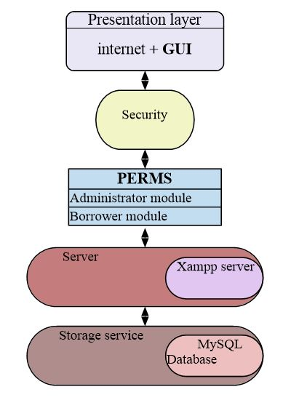

**Figure 1 Architectural design of system**

### System Context Diagram

This is the high level diagram that shows the relationships between a system and its external entities. It is used to provide a clear understanding of the system and its relationship to other systems or external entities. It is often used in systems engineering, software development and business process modeling to show the boundaries of the system and how it interacts with other actors. The diagram usually includes a box or rectangle representing the system of interest and lines connecting it to other shapes representing the external entities with which it interacts. The purpose of a system context diagram is to give a clear understanding of the system’s inputs, outputs and interactions with other systems.

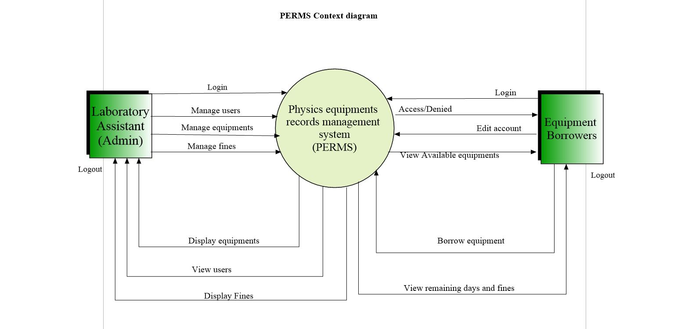

**Figure 2 System Context diagram**

The administrator adds new equipments details as well as new members into the system then he is supposed to notify the member about their new passwords and they are able to login so that they can easily edit their account details, view available equipments for borrow and finally borrow them. The borrower is able to view his/her remaining days to stay with the equipment then also view the due amount so long as one has skipped the deadline. The administrator is able to change the equipment status so that it either makes itself available for borrow and the system also displays the amount due for the imposed fines as well as making scheduled reports.

### Data flow diagram

Data flow diagram is a visual representation of the flow of data through a system. It is used to represent the flow of information in the system, the processes that transform the data and the entities that store or receive the data. DFDs are used to model the logical design of the system, independent of the specific technology or implementation used to build it. The diagram typically consists of series of rectangles, circles and arrows, with each element representing a different aspect of the system. The circles represent data stores and the arrows represent the flow of data between the different elements. DFDs can also be used to model systems at different levels of abstraction, from high-level overviews to detailed diagrams of specific components.

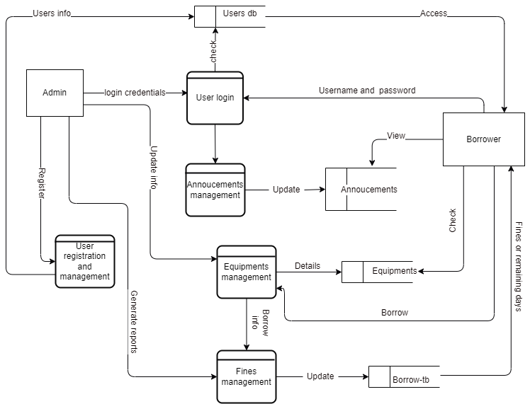

**Figure 3 Perms data flow diagram**

### User case diagram

This is the chart that shows the different activities performed by each entity in the system for example the administrator and the equipment borrower.

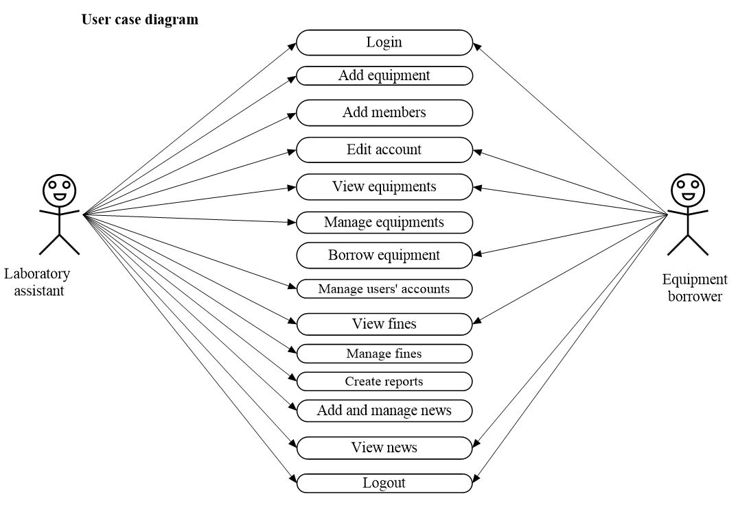

**Figure 4 System use case diagram**

### System Entity Relationship Diagram (ERD)

The entity relationship diagram is a graphical representation of entities and their relationships to each other. ERDs are used to visually organize and plan the structure of a database, including entities, attributes and relationships. The symbols used in ERDs include; squares for entities, diamonds for relationships, lines for linking the entities, cardinalities for showing number of relationships an entity has towards the other. The entities include; Admin, Borrower, News, Equipments and Categories.

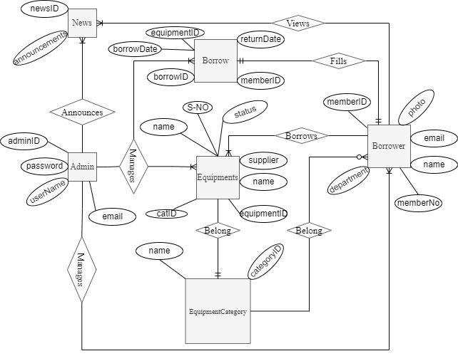

**Figure 5 Perms Entity Relationship Diagram**

### Database Design

It consists of tables, which make up the database schema. Primary keys identifying each entry in the table while foreign keys link the tables with each other. Data consistence checks such as data types, illegal or null submissions or duplicate entries are checked at this level. It was designed based on three structures that is the Conceptual database, Logical database and physical database design phase.

The database design composed of the following objects: tables, security, indexes, keys, columns.

**Table 3 Administrators' table**

|  |  |  |
| --- | --- | --- |
| **Field name** | **Data type** | **Constraint** |
| Administrator ID | Int(11) | Primary key |
| Administrator name | Varchar(60) |  |
| Username | Varchar(150) |  |
| Password | Varchar(150) |  |
| Email | Varchar(150) |  |
| Photo | text |  |

**Table 4 Borrow table**

|  |  |  |
| --- | --- | --- |
| **Field name** | **Data type** | **Constraint** |
| Borrow ID | Int(11) | Primary key |
| Member ID | Int(11) | Foreign key |
| Borrow Date | date | Current-timestamp() |
| Return Date | date |  |
| Equipment ID | Int(11) | Foreign key |
| Borrow Status | enum |  |
| Fine-amount | Varchar(30) |  |

**Table 5 Equipment categories**

|  |  |  |
| --- | --- | --- |
| **Field name** | **Data type** | **Constraint** |
| Cat ID | Int(30) | Primary key |
| Cat Name | Varchar(120) |  |

**Table 6 Announcements**

|  |  |  |
| --- | --- | --- |
| **Field name** | **Data type** | **Constraint** |
| News ID | Int(30) | Primary key |
| Announcements | Varchar(120) |  |

**Table 7 Equipments**

|  |  |  |
| --- | --- | --- |
| **Field name** | **Data type** | **Constraint** |
| Equipment ID | Int(50) | Primary key |
| Equipment Name | Varchar(150) |  |
| Serial-No | Varchar(150) |  |
| Image | text |  |
| Installation date | timestamp | On-update current timestamp() |
| Status | Varchar(150) |  |
| Cat ID | Int(30) | Foreign |
| Supplier name | Varchar(150) |  |

**Table 8 Members/Borrowers**

|  |  |  |
| --- | --- | --- |
| **Field name** | **Data type** | **Constraint** |
| Member ID | Int(11) | Primary key |
| Member No | Varchar(150) |  |
| Username | Varchar(150) |  |
| Password | Varchar(150) |  |
| Email | Varchar(150) |  |
| Department | Varchar(150) |  |
| Member name | Varchar(150) |  |
| Photo | text |  |
| Telephone-No | Varchar(150) |  |

# User interface designs

After designing the different architectures which were to be used in the system, I went on and sketched the different interfaces of the users such that when I reach the implementation stage, it becomes easier for me to translate these designs on to the real system. The different interfaces of the system were all sketched on paper using hands on skills and these designs were later used to implement the system. Some of the samples of the sketches which were used are included below for example the login interface for both admin and the equipment borrowers, then the other pages showing different items according to the session.

## The logging interface

On the sketch it can be seen that one has to have a valid user name and password in order for him/her to access the other system functionalities. This could be possible when one clicked on the login button that is shown at the bottom of the login page.

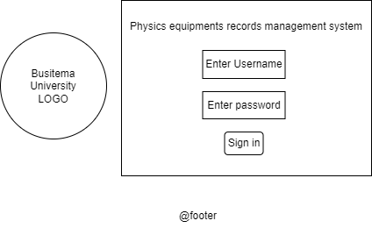

**Figure 6 Login design**

## Welcome page for administrators

Once one logs in as an admin, he would be able to navigate the whole system by clicking on the any page link of their interest. This very page would also allow one to update new laboratory announcements/news.

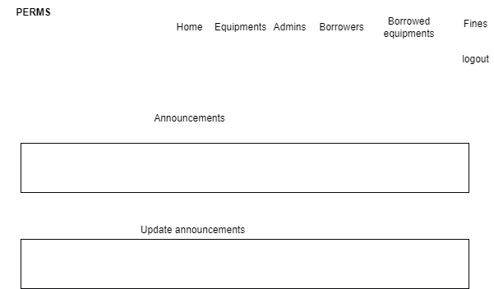

**Figure 7 Admin-welcome design**

**Equipments page**

Here, the administrator could be able to add new equipments, update new changes and also delete the by clicking on the specified buttons in that page.

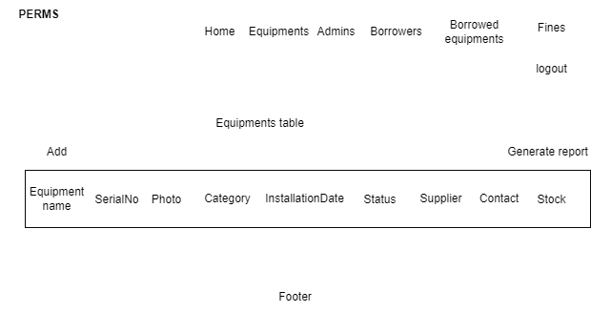

**Figure 8 Equipments page design**

**Borrowed equipments**

The admin still could also be able to view borrowed equipments plus the borrowers details as well as both borrow and return dates so as to ease his work in generating timely reports and this could be possible by opting the generate report button and also scheduling it.

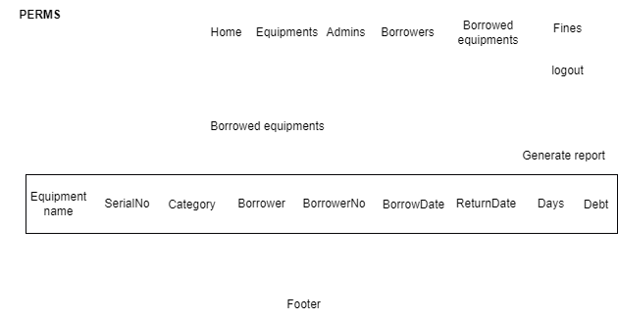

**Figure 9 Borrowed equipments design**

**Fines management**

Further still, the admin could also be able to view borrowed equipments plus the borrowers, stop the counting of the fines for each case, by clicking the stop count button then also ease his work in generating timely reports and this could be possible by opting the generate report button and also scheduling it.

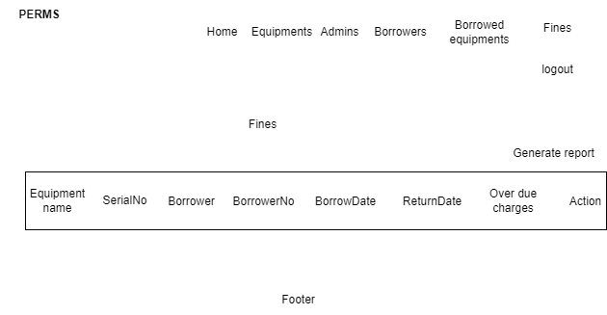

**Figure 10 Fines design**

## Welcome page for equipment borrowers

On this sketch, the borrowers views the updated announcements and is still able to navigate the whole site though the given link.

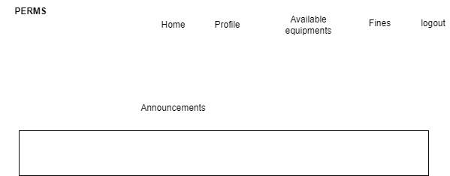

**Figure 11 Borrowers-welcome design**

**Profile**

On this sketch the borrower would be able to view his profile and also free to make changes on it by clicking on the edit button.

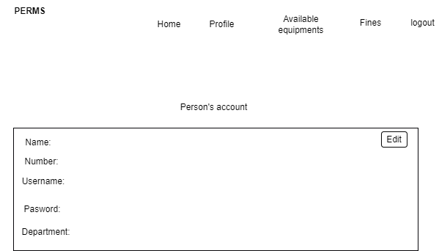

**Figure 12 Borrowers-profile design**

**Available equipments**

Here the borrower would be able to view available equipments with normal status and also not borrowed by any other borrower. He could still borrow the equipment of interest by clicking on the borrow button.

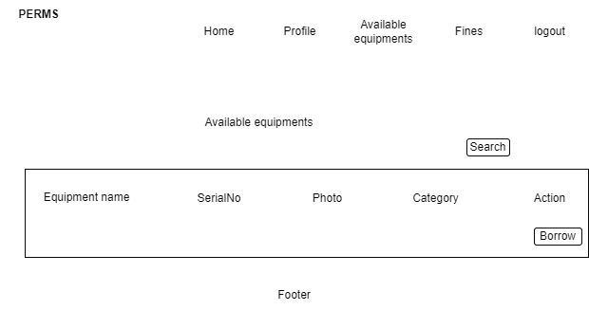

**Figure 13 Available equipments design**

**Fines**

In this interface, the borrower would be able to view the current remaining days for him to use the equipment and also view the overdue amount he owes the technician, having delayed to return the equipment in time.

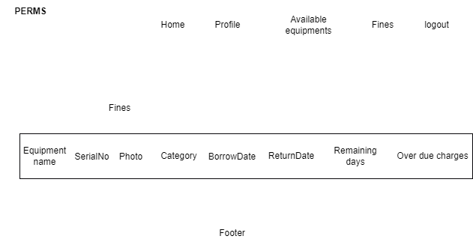

**Figure 14 Borrowers-fines design**

# CHAPTER 5: IMPLEMENTATION AND TESTING

## Introduction:

This chapter emphasizes the actual system implementation. The system was transformed from user requirement into a workable project. The purpose of system implementation was to make sure that correct application is delivered to end users. Besides that, this chapter also emphasizes on how the testing is done to confirm whether it meets user requirements.

## System implementation

The system was designed basing on windows environment. Visual studio code was used to design the user interfaces (front end) while PhpMyAdmin as a DBMS was used to design a database for storing data thereafter a logical connection was established.

**Welcome screen.**

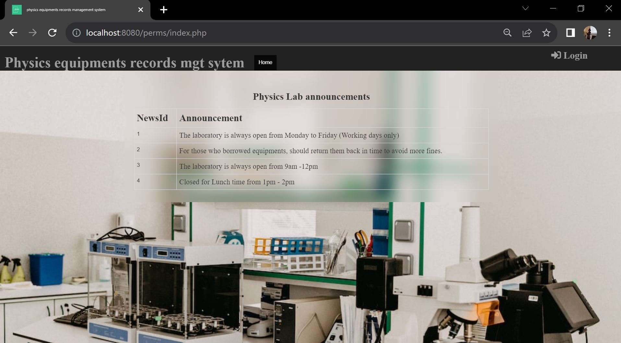

**Figure 15 welcome screen**

**Login page**

This is the first form that comes when the program is launched. It’s mainly meant for security and authentication purposes. When loading the system, one should go to the web browser and type localhost: 8080/perms to open the login page.

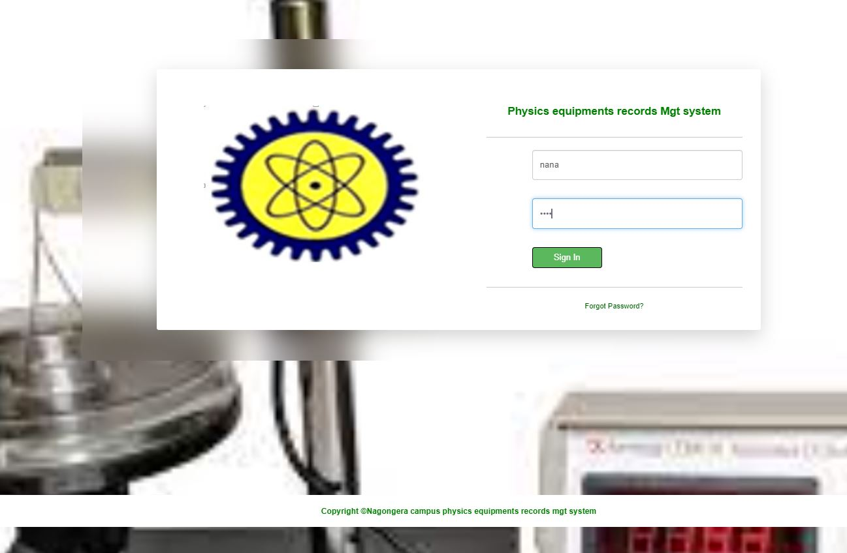

**Figure 16 login page**

**Navigation bar**

From the navigation bar, the admin views the links to all other pages and he is also able to logout from this very page.

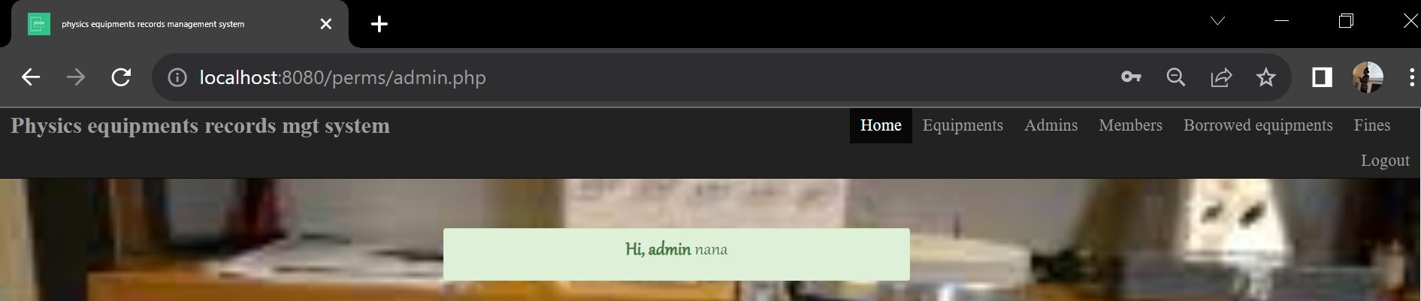

**Figure 17 Navigation bar for admin**

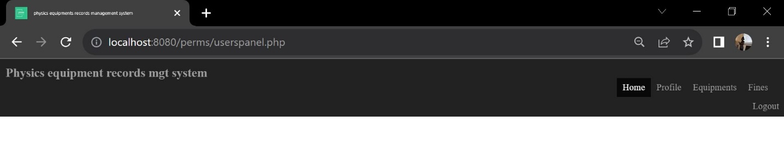

**Figure 18 navigation bar for borrowers**

**ADMIN’S SIDE;**

The administrator was able to login and watch or navigate the whole system and had the privilege to view the borrowers’ password but not for his colleagues to avoid collisions at times. He was able to update news to notify the equipment borrowers about certain conditions in the laboratory.

**Announcements and management**

For example adding, editing news and deleting them.

The announcements were made and uploaded but still could be edited where need be as well as deleted.

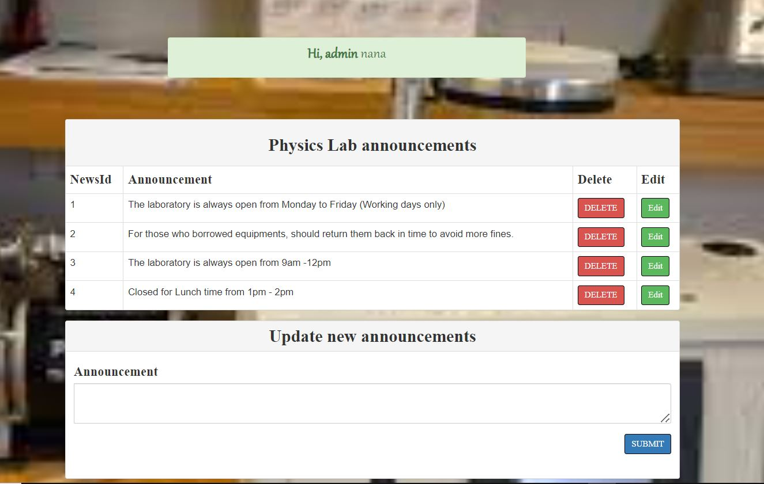

**Figure 19 announcements**

**Administrators and management**

For example adding, editing accounts and deleting them.

The laboratory assistant who acts as the administrator in this project had other work mates who would also act in the same position he was as an admin, reason being, for incase he was absent for work, his colleagues could help him in his space as they give out the equipments but using their accounts. So the main admin registers his co-workers so that they also have their own accounts for the continued service.

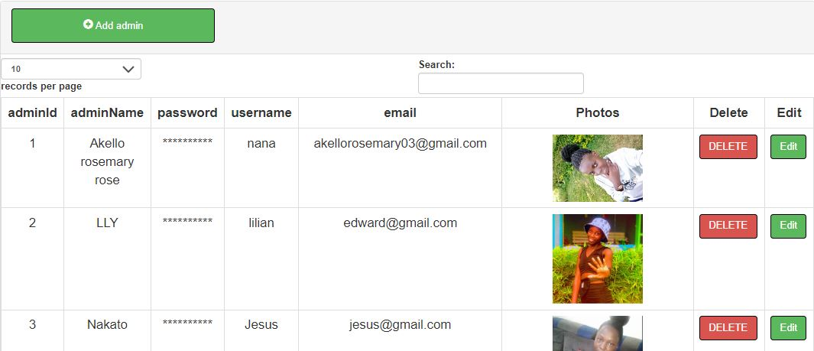

**Figure 20 Administrators**

**Members or borrowers and management**

For example adding, editing accounts and deleting them.

The admin still added the physics lecturers and students who would borrow the equipments for use and he was also able to edit the accounts as well as deleting them.

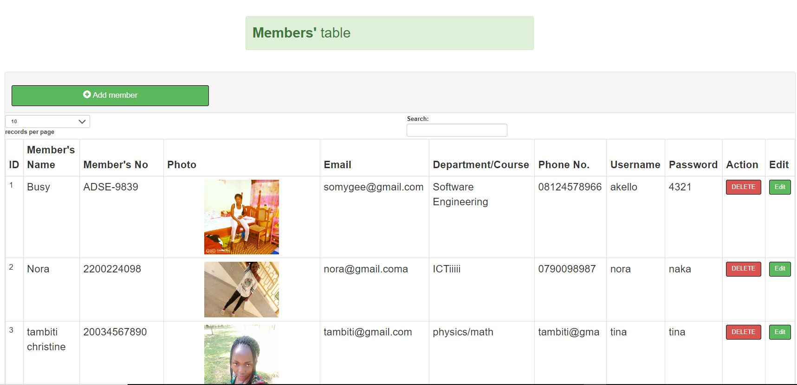

**Figure 21 Borrowers table**

**Equipments and management**

For example adding, editing details and deleting them as well as making reports**.**

Nevertheless, the admin manages the equipments by filling the details of the new equipments, updates their statuses, deletes the details, and then also makes reports about the equipments if necessary.

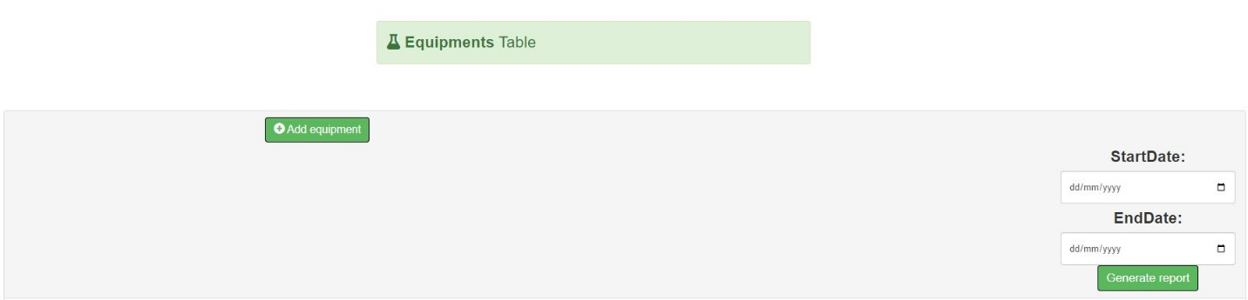

**Figure 22 Generate report**

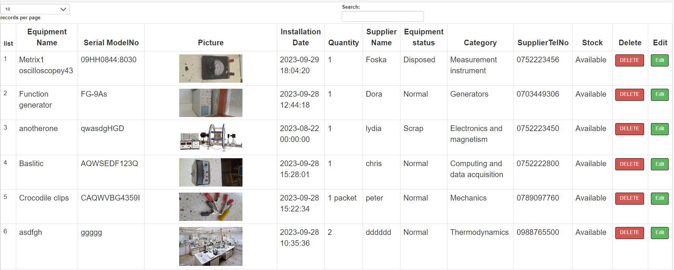

**Figure 23 Equipments table**

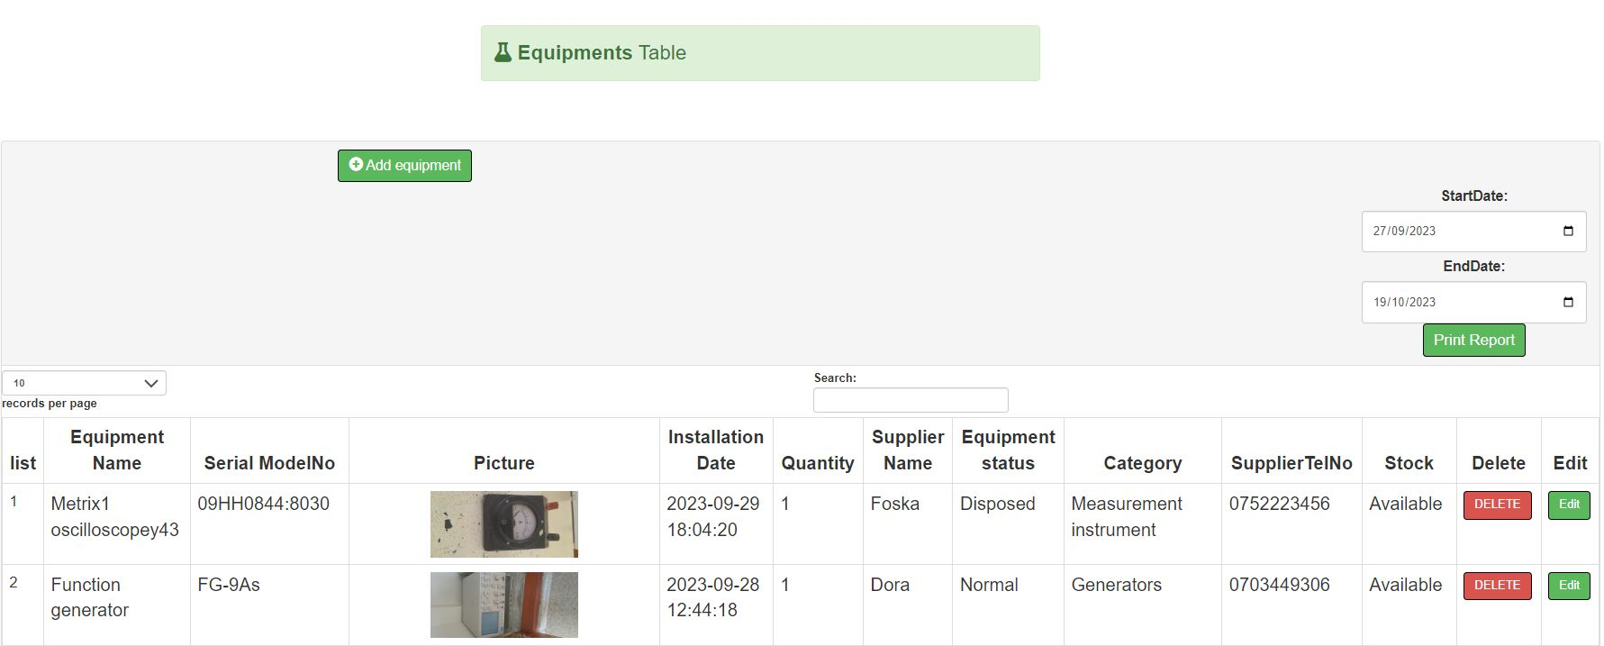

**Figure 24 print report page**

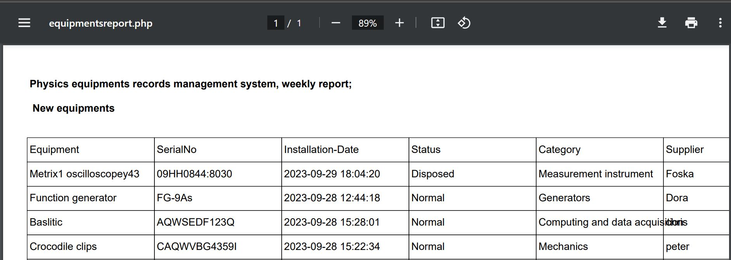

**Figure 25 generated report**

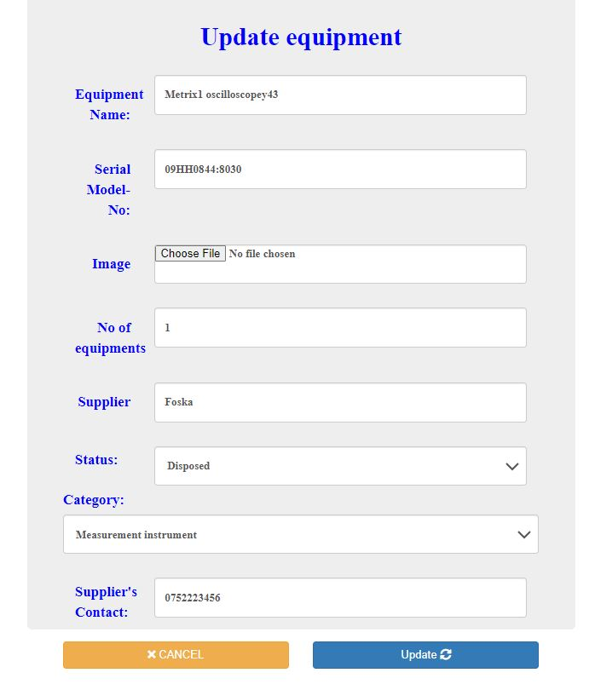

**Figure 26 update equipments**

**Borrowed equipments management.**

Furthermore, the admin views the borrowed equipments and he can also make reports about it for that period.

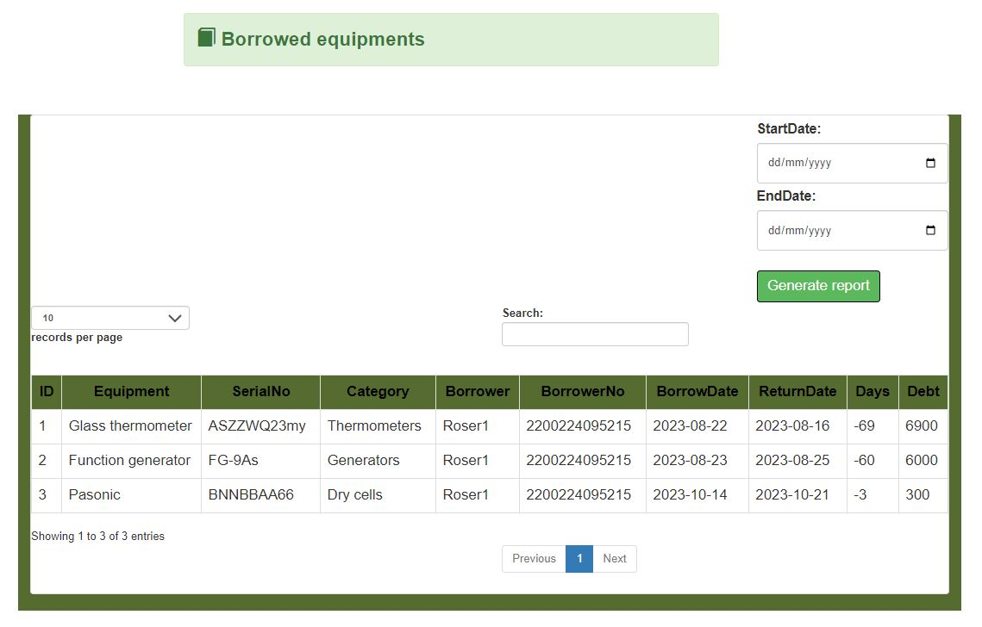

**Figure 27 Borrowed equipments**

**Fines management.**

Lastly, the admin is also able to stop the count of the fines for those who returned the equipments as well as paid the amount demanded. On the same note, he is able to generate reports for the paid and due amount lists.

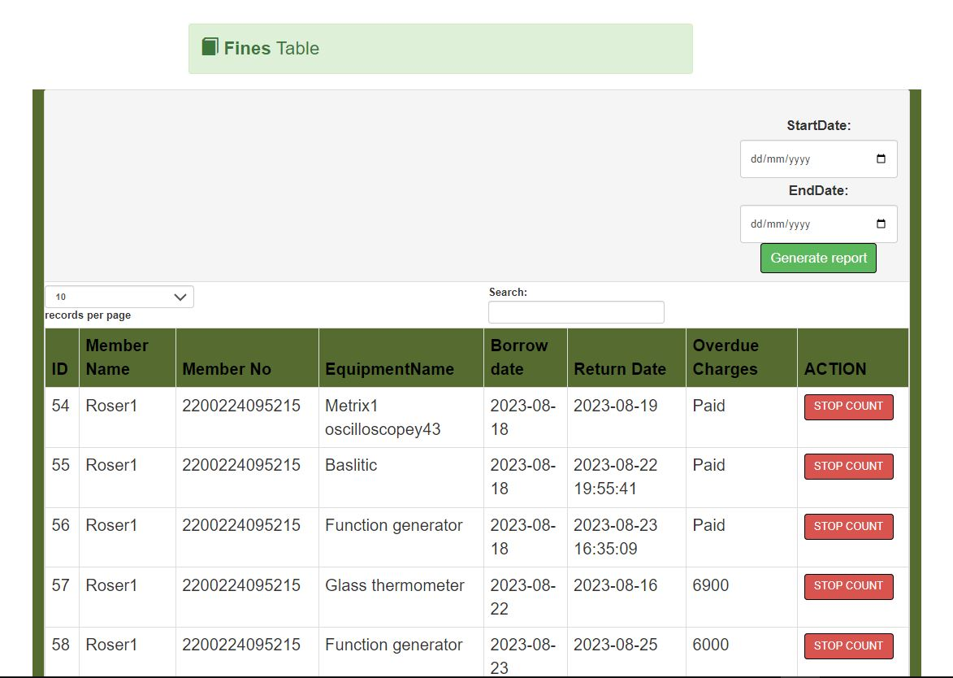

**Figure 28 managed Fines**

**BORROWERS’ SIDE.**

Here, the physics lecturer and students acted in this space as they were supposed to get the login credentials from the system administrator and were able to open and view their profile as well as editing it for example changing password.

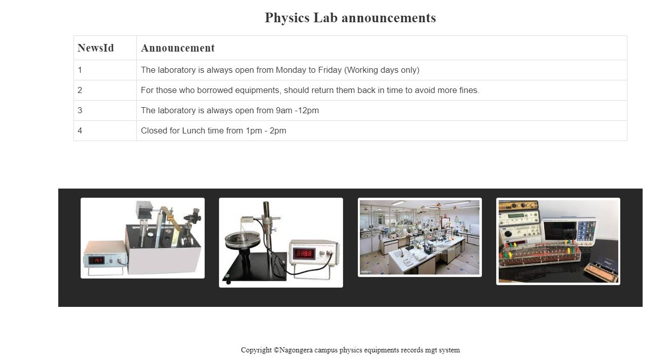

**Figure 29 welcome page for borrowers**

**Member profile and account management**

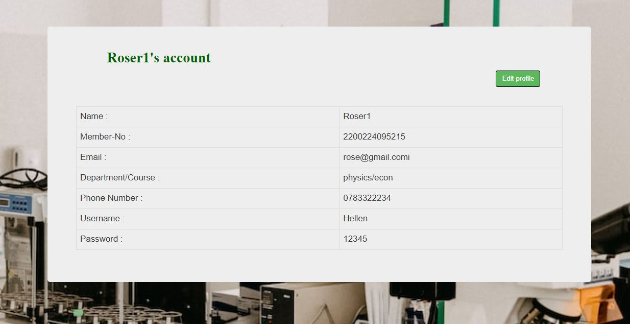

**Figure 30 Borrowers account**

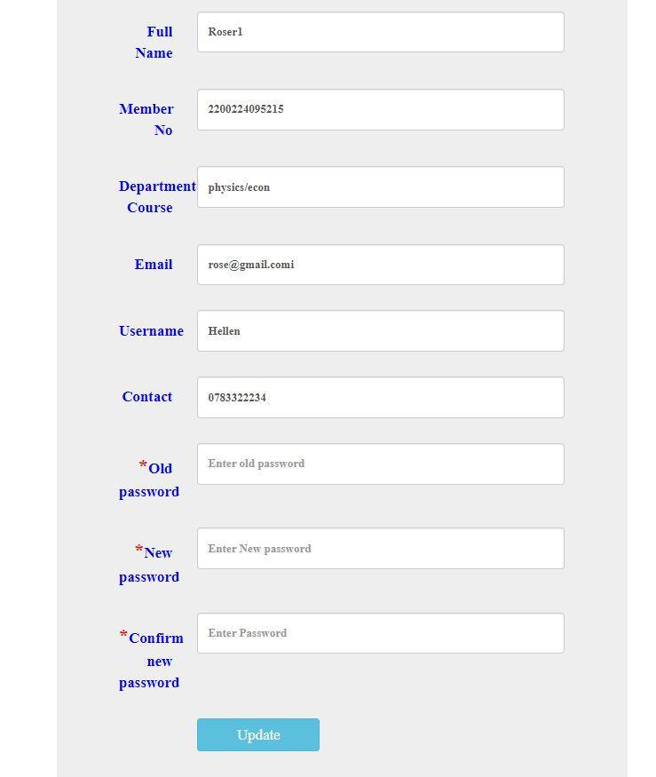

**Figure 31 Borrowers profile edit**

**Available equipments for borrow**

On that same note, the borrowers were able to view the available equipments and choose the one to borrow not forgetting to indicate the return date.

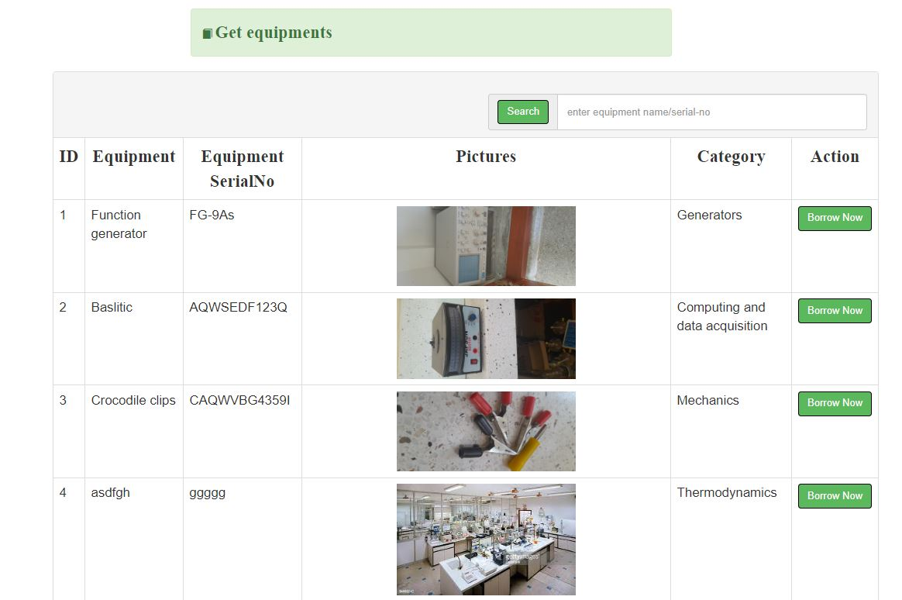

**Figure 32 Available equipments**

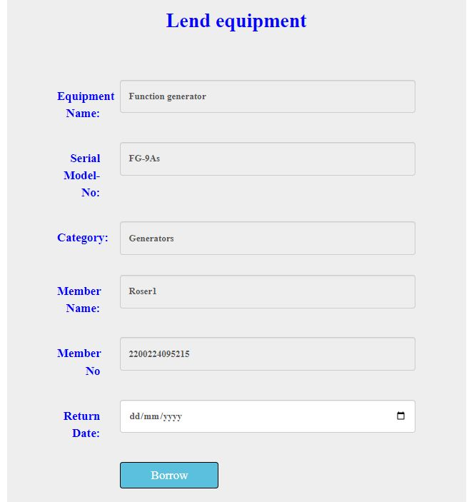

**Figure 33 Borrow page**

**Fines**

Having borrowed and indicated the return date of the equipments, the borrower is able to view the remaining days for him to stay with the equipment as well as the due amount for incase has spent long, passed the return date he promised.

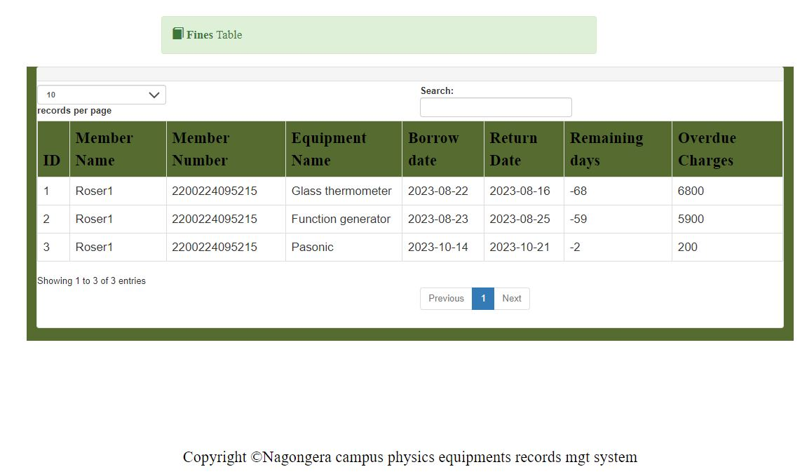

**Figure 34 borrower's fines**

**Data storage**

The system automatically stored the admin login details, borrowers’ details, equipments, categories, borrow sessions and announcements into the system database “perms” in tabular form. Some of the database tables include;

**Admin-table**

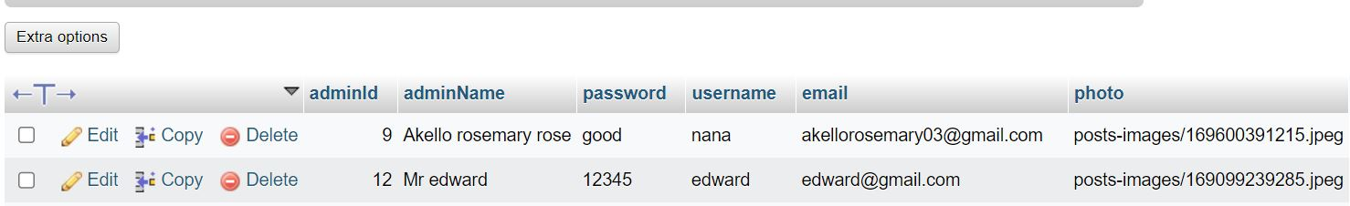

**Figure 35 admin-tb**

**News-table**

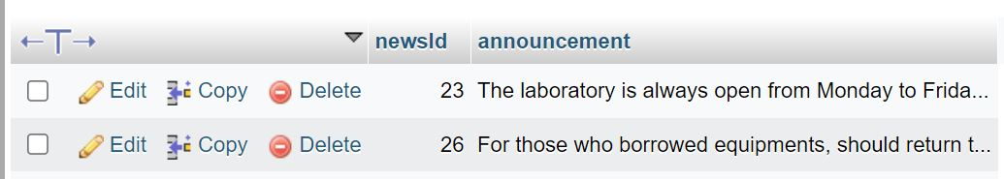

**Figure 36 News-tb**

**Equipments-table**

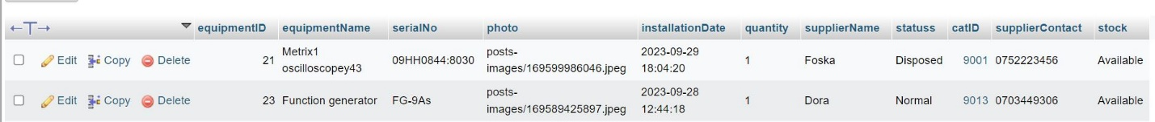

**Figure 37 Equipments-tb**

**Equipments Category-table**

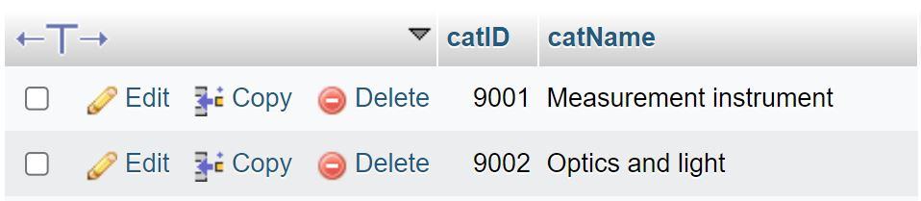

**Figure 38 equipmentsCategory -tb**

**Borrow session-table**

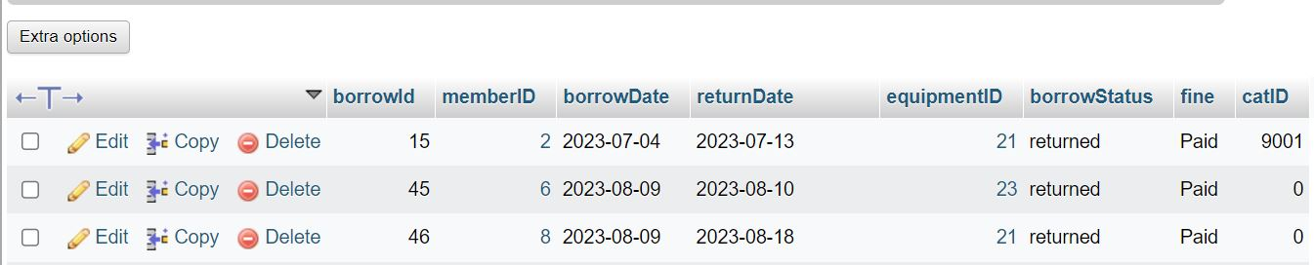

**Figure 39 Borrow -tb**

**Borrow session-table**



**Figure 40 Borrow-tb**

## System testing

The entire system was tested using codes, class modules and modules. This stage of implementation ensured accuracy and efficiency operation of the system before it was given to the users. It required a series of different tests which varied at different system levels. The system tester assumed that if all parts of the system were correct then the goal would have finally been achieved.

Testing the process of executing the program in order to identify errors or bugs. Test shows the software errors. Therefore, testing was done after completion of the system. This was done in two formats including Unit testing and Integration testing.

### Unit testing;

This was done on individual codes of the system to ensure that they fully yield the functional units and it was done by examining each unit, for example the code for adding new equipments and displaying tables that showed items inserted successfully. This therefore gave me a go ahead for integration testing after all the identified errors were individually worked on.

### Integration testing;

This was done after all the different modules had been put together to make a complete system. Integration aimed at ensuring that all the modules of the system worked hand in hand and that they could be integrated to form a complete working system.

# CHAPTER 6: DISCUSSION, CONCLUSION, RECOMMENDATIONS, LIMITATIONS AND FUTURE WORK

## Introduction:

In this chapter, we discussed the findings for developing the physics equipments records management system in relation to the set objectives and methodology. The study found that the University fully relied on the manual system of keeping equipments records. The physics equipments records management system (perms) that was developed focuses on replacing the manual system for efficient record keeping process and accuracy in data storage. The implementation of the proposed system involved the campus laboratory assistant as the administrator, the physics lecturers and students as the equipment borrowers which were discussed as shown below.

## Discussion

The discussion of this chapter is based on the theme of objectives stated in chapter one.

* **Determination of the requirements.**

The requirements of the study were got from two sources. These include; Library research and field research. Under Library research, the study was conducted on the previous done projects about the same topic. This guided me on the alignment of my project work. The library research generated requirements that were used in the design of the DFD database design and a few others which led to the fulfilment of functional and non-functional requirement. The field research helped me to get to know how the manual system works, their view and perception towards the web-based physics equipments records management system which also generated the requirements that were used for designing the interfaces.

* **Designing of the Physics equipments records management system (PERMS).**

The system was designed depending on the requirements followed by the RAD from the SSADM. The stage of design included Architecture, Context Diagrams, and DFDs, Use case diagrams and data base design, which enabled the smooth flow of data. Design and evaluate the effectiveness of PERMS, encouraged the use of the different stages of design.

* **Implementation of the Physics equipments records management system**.

The implementation of the system design was carried out using the implementation tools which included. Visual studio code, Chrome, MySQL, HTML, Xampp and windows in order to fulfil the implementation where I came up with the interfaces in chapter 5, which interfaces include: “login, managing user accounts, equipments and fines as well as borrowing equipments”. The system was implemented to run parallel with manual system as the users adopt to it slowly.

* **System testing and validation**

After system implementation, the next step was testing and validating of the system which was done by guiding the users on how to use the system. The study was carried out and it was discovered that most of the users agreed that the system was able to solve the existing problem.

## Conclusion

The system was implemented and tested since the lab assistant was able to insert his details as well as in putting some equipment details and generating a report as a trial test. The system was operated at a high level of efficiency and all the physics lecturers and students associated with the system thus understanding its advantage. The system solved the problem that it was intended to solve as to the requirement specification, so I conclude that the system can be used in University/school/institute laboratories.

## Recommendations

I recommend that my physics equipments records management system should be adopted by the learning institutions and used by the laboratories like for physics, chemistry, biology, computer, as well as stores to properly and safely keep records of the item details.

In the same spirit, I would wish to recommend the University to fully adopt to students’ final year projects if necessary, instead of just fulfilling the sake of student’s graduation.

Lastly but not least, the University should give enough time and other resources to students to fully make their projects other than putting abrupt schedules in the due course as well as consulting from them about the system functionalities in future when adopted.

## Limitations

A few challenges like limited funds, limited access to power, limited data for remote project supervision, limited time, poor internet connection (network), limited knowledge about some programming languages and conflicting ideas from different sources. Some processes did not go on perfectly and thus other things were not done.

## Future work

Due to time influence, the researcher was not able to include all the features into the system. Therefore system has few functionalities and one interested should read through and focus on adding on some missing activities and other modules into the system like admin password recovery, among others. System maintenance should done through in order to improve on the system performance. The researcher should also try using other programming languages plus evolving technologies to improve on the system.

# REFERENCES

(2009). Case study research : design and methods. London, SAGE.

(2009). Research design : qualitative, quantitative, and mixed methods approaches. Los Angeles ; London, SAGE.

Bourne, S. R. (1982). The UNIX system. London, Addison-Wesley.

Brown, R. G. (2013). Introductory Physics I.

Danjuma, T. and M. Adeleye (2015). "The Effect of the availability and utilization of laboratory apparatus in the teaching of physics: A Case study of secondary schools in Karu LGA, Nigeria." Research Journal of Educational Studies and Review **1**(5): 118-122.

Dickson, G. W. and J. C. Wetherbe (1985). The management of information systems, McGraw-Hill, Inc.

Goffman, E. (1967). Interaction ritual : essays on face-to-face behaviour. N.Y., Doubleday.

Gurikar, S. G. (2015). "The Emergence of Physics as a Study and its Importance in Society-An Analysis." IJRAR-International Journal of Research and Analytical Reviews (IJRAR) **2**(2): 344-351-344-351.

McLeod, J. and C. Hare (2006). How to manage records in the e-environment, Psychology Press.

Yin, X., et al. (2022). Introduction to spectroscopic ellipsometry of thin film materials : instrumentation, data analysis and applications. Weinheim, Wiley-VCH.

Young, P. V., et al. (1947). Scientific social surveys and research : an introduction to the background, content, methods and analysis of social studies. N.Y., [s.n.].

ISO Standard - 15849 - Information and Documentation - Records Management

Novianti, R. R. (2011). DEVELOPING STUDENTS’SPEAKING ABILITY THROUGH GENRE-BASED TEACHING. Indonesia: Universitas Pendidikan.

Suseno, N. H. (2019). School laboratory management information system. IOP Publishing.

Webster, M. (2002). Merriam-Webster's Rhyming Dictionary. Merriam-Webster.

# APPENDICIES

## APPENDIX A: Open-ended interview questions

**Introduction**

Dear respondent,

My name is Akello Rosemary, Busitema university student, Faculty of science and education, pursuing a Bachelor’s degree in Information Technology. Am carrying out a research study on physics equipments records management system.

This survey is to guide me into understanding the current records management system in the physics laboratory at faculty of science and education of Busitema University. I humbly request for your cooperation in answering the following questions. Any information provided will be for academic benefits only and will be treated with absolute confidentiality.

Thank you.

**Questions;**

**To the laboratory assistant**

1. How many students do physics as a subject?
2. How many lecturers lecture physics as a subject?
3. How many equipments do you think you have in this place?
4. How do you pass information to equipment users in this place for example announcements?
5. How do you keep information about the equipments and the borrowers’ details?
6. Do you find hard time while taking new stock?
7. Do you make scheduled reports about the life time of those equipments?
8. If yes, do you find hardships when making them?
9. Do you allow equipment users to use the equipments while in other locations other than this place?

**To the physics lecturers and students (equipment borrowers)**

1. How do you borrow the physics laboratory equipments?
2. How long do you take while using the equipments for your research and experiments?
3. Are you allowed to move with the equipments out of the laboratory?
4. How do you get updated information about the equipments from the laboratory assistant?
5. Do you think moving with the equipments to your own places of comfort for further and experiments and research can be of great improvement to your activities?

**Thank you for your cooperation and time, May GOD Bless you.**

## APPENDIX B: TIME SCHEDULE

|  |  |  |
| --- | --- | --- |
| **Activity** | **Duration** | **Deliverables** |
| Formulation of the title | 3rd to7th  July,2023 | Project title |
| Formulation of the problem | 10th to 14th July,2023 | Problem statement |
| Selecting the objectives | 17th to 28th July,2023 | Compile |
| Literature review | 2nd to 12th August,2023 | Record |
| Choosing the methodologies | 15th 24th August,2023 | Record |
| Data collection | 18th to 23rd September,2023 | Recording results |
| Data analysis | 25th to 30th September,2023 | Analysis |
| System design and implementation | 4th to 24th October,2023 | System interfaces |
| Testing and validation | 25th to 31st October,2023 | Getting correct results |

**Table 9 Project time schedule**